1. 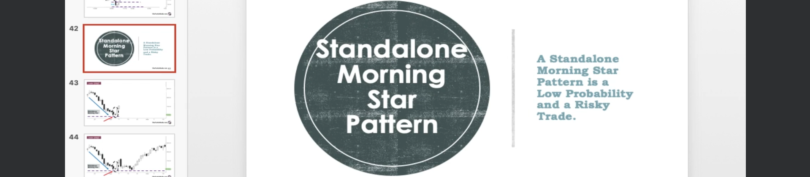  
   We also saw Standalone Hammer, Bullish Engulfing and Piercing Pattern.
2. If A Morning Star doesn’t support the confirming prior support, it is low probability and a risky trade.
3. 